# SOC JS Playback Engine – SDK Services - High Level Specifications

V.1.03

Author: marius alexandru

Contents

SOC JS Playback Engine – SDK Services - High Level Specifications 1

I. SDK Services – General Scope 2

II. SDK Services – Class Hierarchy 3

II.A. SDK Services – Class Hierarchy - Diagram 3

II.B. SDK Services – Class Hierarchy – Description 3

III. SDK Services – Interfaces 4

III.A. SDK Services – Interfaces - Diagram 4

III.B. SDK Services – Interfaces – Description 4

# SDK Services – General Scope

The scope of SDK Services is to ensure a multiplatform compatibility of the SOC Multiplatform Player

The **“SDK” Services** - is a hierarchy of SDK services having as root class A_SDK_JsTV class (with A - meaning “*A*bstract”). This hierarchy will encapsulate the specificity of each TV Signage OS and also (via additional subclasses) the specificity of each new Firmware inside each TV OS.

**Why are needed?**

The implementation of the SDK Services is needed in order to encapsulate all the specificity of different WebTV OS Systems.

All the other services, that used the SDK functionalities as clients, will work only with the SDK abstract service “A_SDK_JsTV” in order.

This “A_SDK_JsTV” (A is the notation for abstract) will offer a set of interfaces that will not depend on the specificity of each system

There are 2 types of Java Script/TV “system specificity” :

* A major one : TV OS Types / Node.js / etc.. (ex. Tizen OS, WebOS, Node.js etc...)
* A minor one : The “”ongoing” versions inside a specific OS (= firmware/SDK versions)

This situation is modeled via a hierarchy a SDK classes that will have on top the abstract service A_SDK_JsTV

# SDK Services – Class Hierarchy

## II.A. SDK Services – Class Hierarchy - Diagram

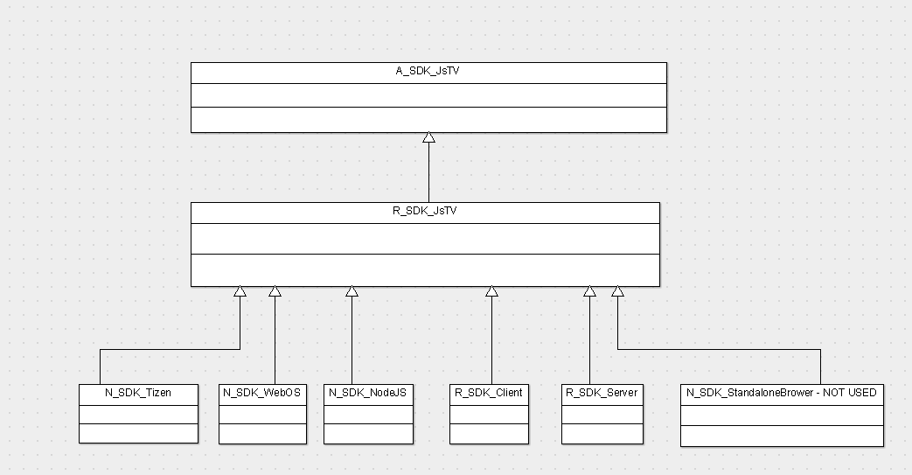

## II.B. SDK Services – Class Hierarchy – Description

1. A_SDK_JsTV –
2. A_SDK_JsTV –
3. A_SDK_Tizen –
4. A_SDK_WebOS –
5. A_SDK_NodeJs –
6. A_SDK_Client –
7. A_SDK_Server –
8. A_SDK_StandaloneBrowser – NOT USED

# SDK Services – Interfaces

## III.A. SDK Services – Interfaces - Diagram

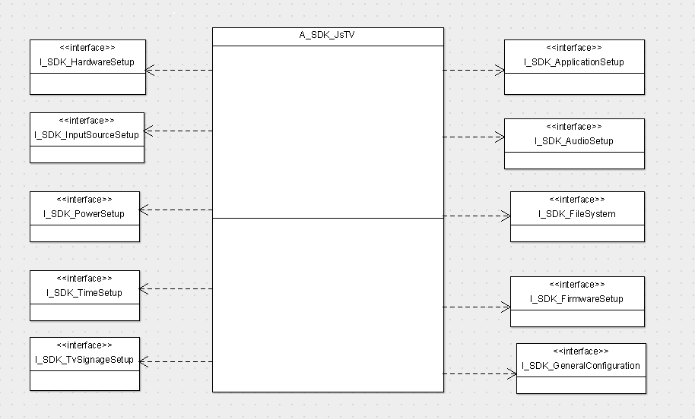

## III.B. SDK Services – Interfaces – Description

1. I_SDK_ApplicationSetup –
2. I_SDK_AudioSetup -
3. I_SDK_FileSystem -
4. I_SDK_FirmwareSetup –
5. I_SDK_GeneralConfiguration -
6. I_SDK_HardwareSetup -
7. I_SDK_InputSourceSetup -
8. I_SDK_PowerSetup -
9. I_SDK_TimeSystem -
10. I_SDK_TvSignageSetup -